Rur-ple final project

Fisrt of all, we start by initializing the variables that we will need to use along the code.

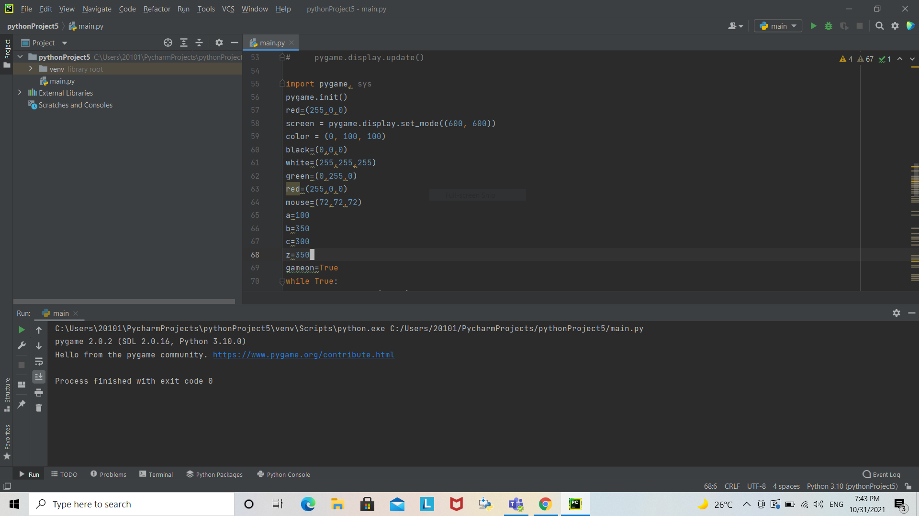

Secondly, we start the loop game and start to build our game.

We start by adjusting the variable that controls the speed of the cat

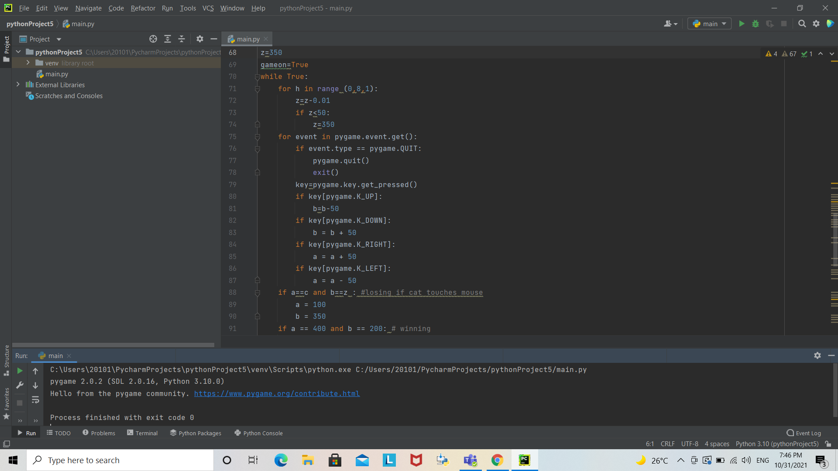

A quit code is created

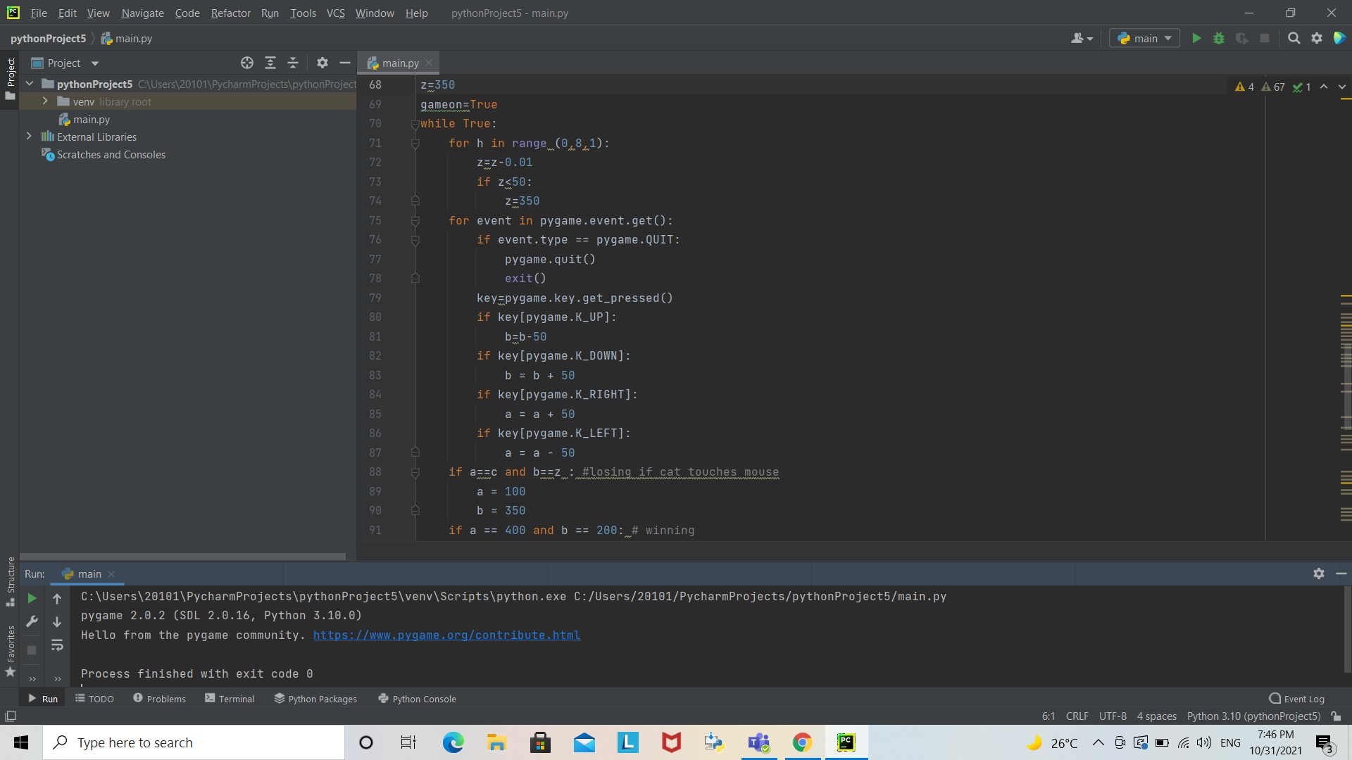

Then, we controls how the mouse will move using the arrows



Our first losing scenario is when the mouse touches the cat



Our second losing scenario is when the mouse get out of his boundaries and touch the water(the blue blocks)

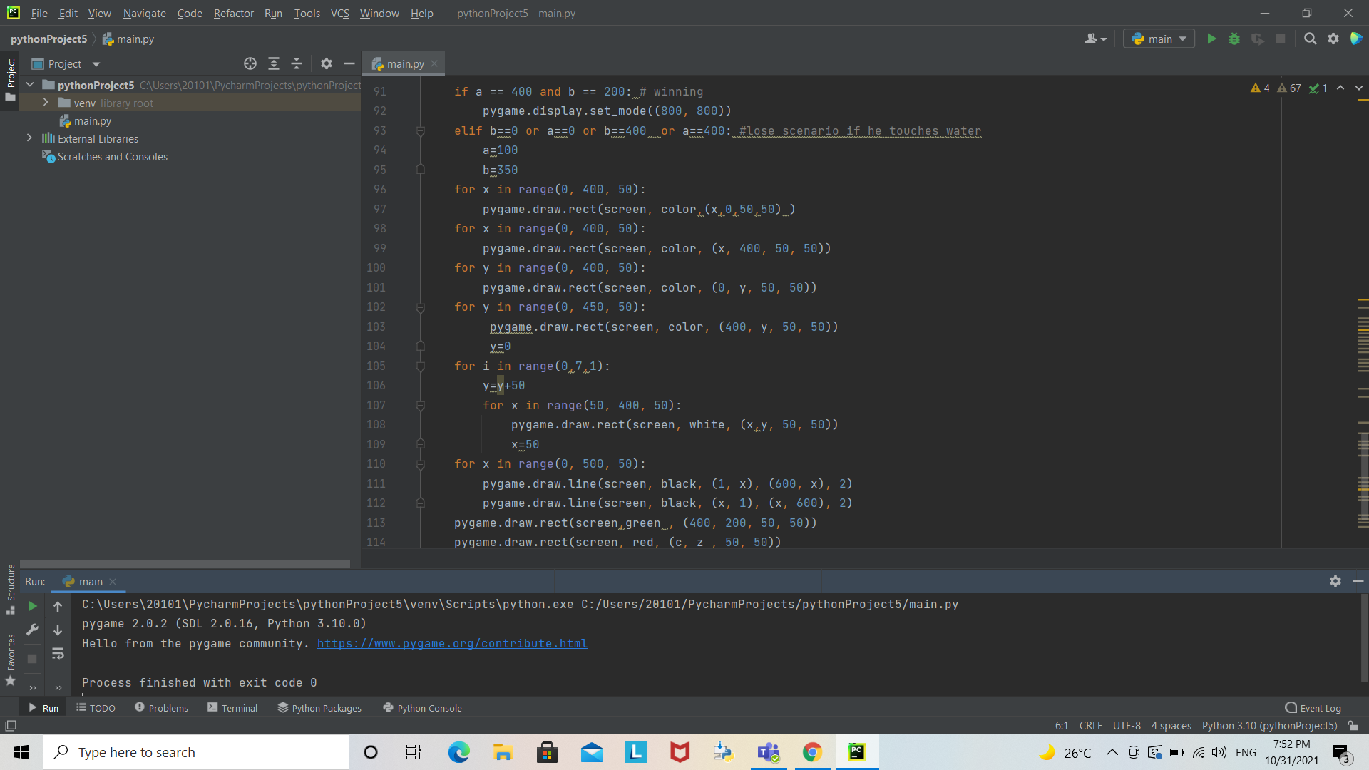

Our winning scenario is when the mouse passes the cat successfully and pass through the green block.



Here, we are creating our sequence of each block such as water and playing area.



We controls the coordinates that the mouse will move by.

We were also initializing the shape of each component.

The game was updated at the end

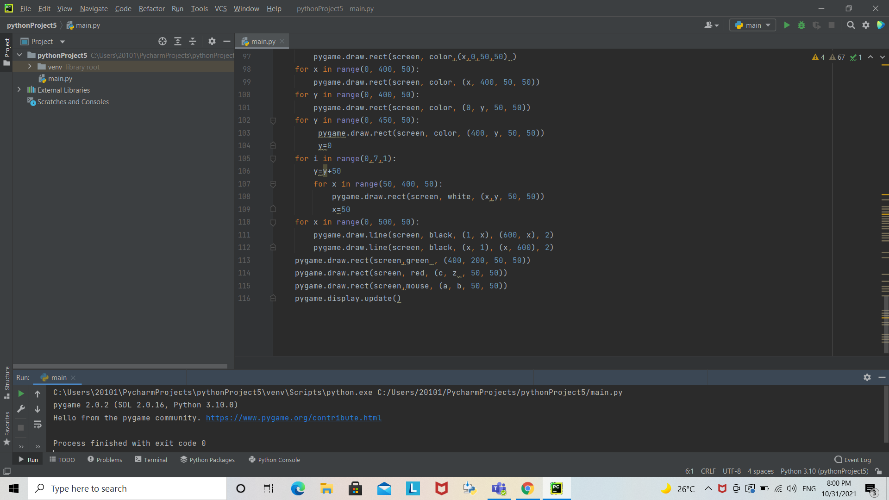

Project by: Ismail Magdy, Amr Ayman, Ahmed Wagdy

Facilitators: Ahmed Hatem, Radwa Galal